Suggested School Supply List (All Willoughby Home Room Students)
Ms. Willoughby will teach Willoughby and Carlton’s students math, Social Studies and science.
Ms. Carlton will teach Willoughby and Carlton’s students ELA and will have a separate supply list for her home room students.

Four packs of pencils (Ticonderoga, preferred. Others just break when sharpened and wastes class time.)

Pencil top erasers (5 or more packs) (usually 10 cents a pack during back to school sales)

2 – 1” binders

6 one-subject notebooks (Meijers usually has them for ten cents)

1 highlighter

2 blue pens

2 boxes of tissue

1 canister Lysol Wipes
1 mini combination lock. 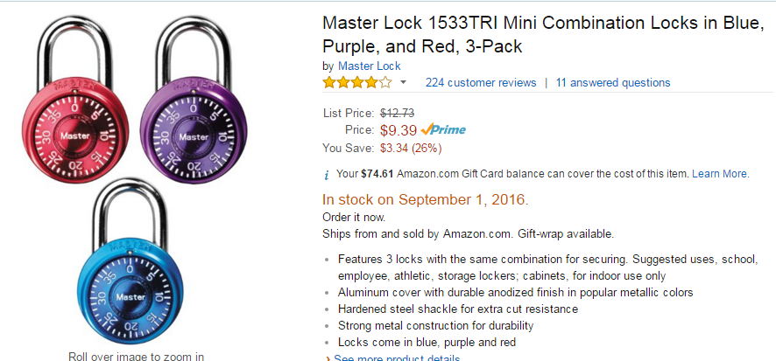
I have only found these on Amazon.com however some have seen them in other stores. ONLY THE MINI LOCKS WILL WORK ON OUR LOCKERS. These only come in a three pack. If you want to donate your extras, we’ll take them! We have issues with these throughout the year.

